# **CS316 Project Report**

## Introduction

We plan to build a web-based user interface that visualizes information on terrorist events around the world from 1970 to 2016. We obtain the data from an open-source database called the Global Terrorism Database (GTD) (https://www.start.umd.edu/gtd/). The database consists of more than 170,000 cases including information such as the incident date, location, attack information, weapons used, target/victim information, perpetrator information, casualty information etc.

The GTD is currently the most comprehensive unclassified database on terrorist events in the world. However, the website that holds that GTD lacks a nice visualization that can illustrate the data comprehensively. It only includes a static world map that shows the intensity of terrorist attacks around the world, but omits a lot of the other interesting attributes. Our goal is to develop a web-based user interface that enables users to interact with the data and to produce visualizations based on the features that the user selects.

## Assumptions and E/R Diagram

Based on the GTD codebook, we make several reasonable assumptions about the dataset and propose the E/R diagram (shown in Figure 1) as follows.

* Terrorism incidents have a key (id) and other attributes including date, number of deaths (nkill), number of injuries (nwound), whether having property damage (property_damage), and whether nationalities of perpetrators different from the country of the attack (international).
* A terrorism incident can only have happened at one location. Location information includes country, province/state (prov_state), city, and latitude and longitude of the city. Latitude and longitude represent the center of the city where incident occurred and serve as a primary key for the location entity set.
* Perpetrators, who initiated terrorism incidents, have group names (gname) as a key. Each incident can only have been initiated by one group of perpetrators.
* The weapons used in each incident can only belong to one category of the weapon types.
* Each incident had only one general type of victim (type), such as business, government, and educational institution. Each general type has multiple subtypes (subtype), which capture more precise target categories. For example, if the target is the government, it could be government personnel, judges, or politician. The specific person, building, and installation (target) that were targeted are also recorded. Type, subtype, and target serve as a key for the victim entity set.
* Each incident belonged to one class of attack. Attack is uniquely identified by type, successfulness of an attack (successful_attack), and whether being suicide attack (suicide_attack).
* On our website, users could leave comment. The comment entity set has three attributes, including user_id, name, and message. User_id is the key here. A user could leave several messages using the same name but each message will be assigned a unique user_id. Comment is not necessarily related to certain event.

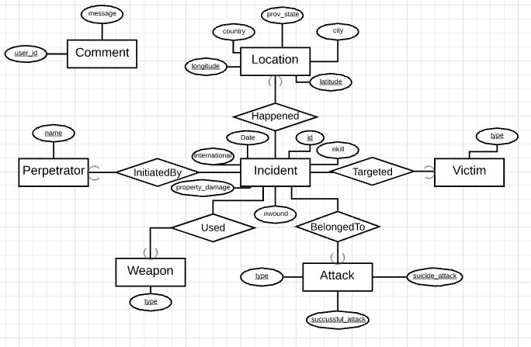

subtype

target

name

Figure 1 E/R Diagram

## Relations and Constraints

We first translate the E/R design directly into relations with keys underlined.

* Incident (id, date, international, property_damage, nwound, nkill)
* Location (latitude, longitude, country, prov_state, city)
* Happened (latitude, longitude, incident_id)
* Perpetrator (name)
* InitiatedBy(perpetrator_name, incident_id)
* Weapon (type)
* Used (incident_id, weapon_type)
* Attack (type, succussful_attack, suicide_attack)
* BelongedTo (incident_id, attack_type, succussful_attack, suicide_attack)
* Victim (type, subtype, target)
* Targeted (incident_id, victim_type, subtype, target)
* Comment (user_id, name, message)

The relation InitiatedBy has all the information in the relation Perpetrator, so we can merge these two relations and only keep InitiatedBy. Similarly, we can merge Weapon with Used, Attack with BelongedTo, and Victim with Targeted. Then we got the following tables with constraints stated.

* Incident (id, date, international, property_damage, nwound, nkill)
  + As key, id should not be NULL. Attribute international and property_damage can only be 0 or 1. Attribute n_wound and nkill should not be less than 0.
* Location (latitude, longitude, country, prov_state, city)
  + Attribute latitude and longitude should not be NULL. Latitude should be within [-90, 90], and longitude should be within [-180. 180]. The combination of country, prov_state, and city is a unique key.
* Happened (latitude, longitude, incident_id)
  + The pair of latitude and longitude references latitude and longitude in the Location table. Incident_id references id in the Incident table.
* InitiatedBy(perpetrator_name, incident_id)
  + Incident_id references id in the Incident table. Perpetrator _name should not be NULL.
* Used (incident_id, weapon_type)
  + Incident_id references id in the Incident table. Weapon_type should not be NULL.
* BelongedTo (incident_id, attack_type, succussful_attack, suicide_attack)
  + Incident_id references id in the Incident table. Attack_type, successful_attack, and suicide_attack should not be NULL. Successful_attack and suicide_attack can only be either 1 or 0.
* Targeted (incident_id, victim_type, subtype, target)
  + Incident id references id in the Incident table. Victim_type, subtype, and target should not be NULL.
* Comment (user_id, name, message)
  + User_id, name, and message should not be NULL. Similar to twitter, each message has a 200 character limit.

## Design of Web Interface

Our web interface consists of three parts. The first feature is to produce a world map (as shown in Figure 2) that shows the intensity of terrorist events for a given time period. The intensity can be measured as the frequency of terrorist events, or a combination of incident fatalities and injuries. When the user selects a period of time and the type of intensity that he/she is interested in, a world map will appear with different colors indicating different levels of intensity.

Our second feature allows users to closely examine the terrorist events for a given location and for a given time period. If the user is interested in seeing the trend of terrorist events over years, the user can select the “trend” button, which generates a line plot with the time period on the x-axis and the preferred intensity measure as the y-axis. This provides information for the user to analyze how the intensity of terrorist event changes over years. If the user is interested in finding out more detailed information about an event, the user can choose the features of interest and click on the “distribution” button. Then a pie chart will be displayed, showing the proportion distribution of the feature. These features include the attack type, weapon type, target/victim type and perpetrator type.

Our last feature enables users to leave messages about their thoughts or feelings. Users can also browse through others’ comment. We are also thinking about letting users report terrorism events, so that we can collect data. However, users report is not authentic and may contaminate our original dataset. We may need some help from the course staff before we make up our mind.

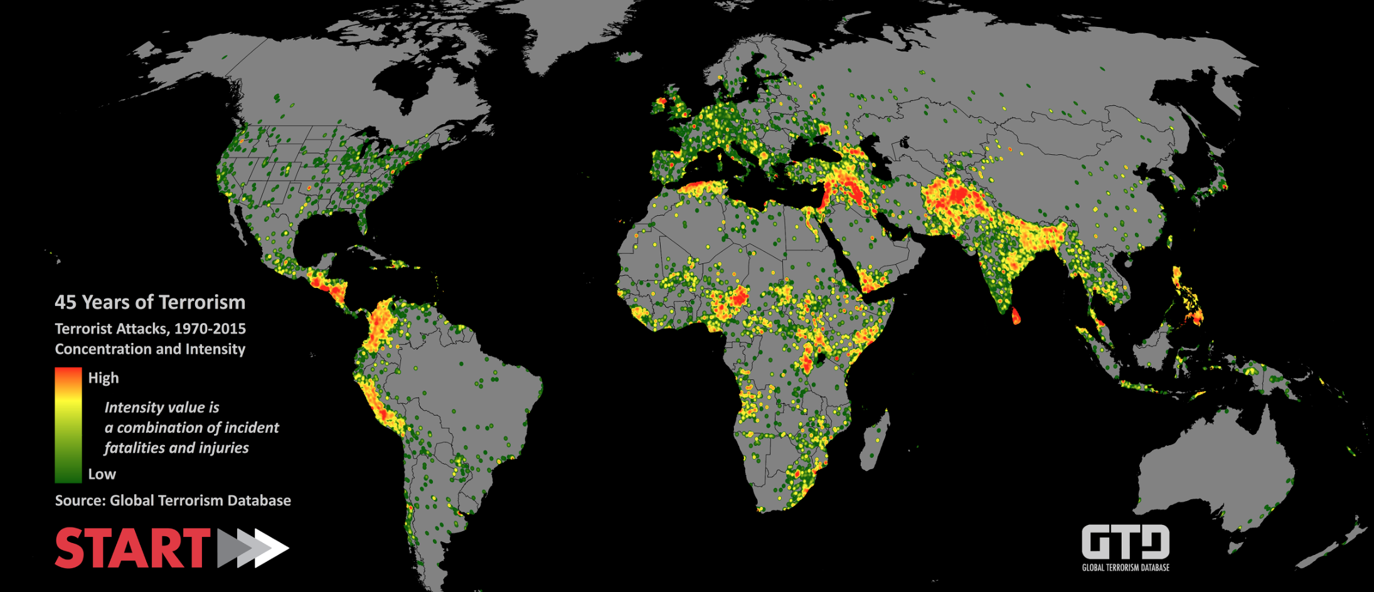

Figure 2 World Map of Terrorism